Asa Hayes

GEOG-361-502

Lab 2

Q1. What is a “raw” image? What are the possible reasons for geocoding and coregistering a raw image?

A raw image is a sensed image that has not been fit to a set of coordinates. While it may be correct based on the sensor used, it may not fit correctly with coordinate systems used to survey the area, and thus needs to be fit and geocoded with another verified image to ensure it conforms to the geographic coordinate system used for that area.

Q2. What are ground control points (GCPs)? Why does the polynomial geocoding method need GCPs? What are favorable locations for GCPs?

GCPs are the points that the rectification process is based off of. As the points are assigned to be the same location on both the image and a real map, this allows for transforming of an area on the image to better fit the same area on the map, which is the basic explanation for the polynomial geocoding method. The best locations for GCPs are usually permanent and should be as clearly distinguishable on both images as possible.

Q3. Why does the geocoding process involve image resampling? What are the three commonly used resampling methods?

Resampling is the process that alters the image coordinates to fit the map better. The three most commonly used methods are Nearest Neighbor, Bilinear Sampling, and Cubic Convolution.

Q4: Insert your GCP file as a table in the report. Discuss why these locations were selected as GCP points.

|  |  |  |  |  |  |  |  |  |  |
| --- | --- | --- | --- | --- | --- | --- | --- | --- | --- |
|  | Base X | Base Y | Warp X | Warp Y | Predict X | Predict Y | Error X | Error Y | RMS |
| 1 | 4016.75 | 4586.75 | 2840.00 | 5968.50 | 2846.13 | 5962.74 | 6.13 | -5.76 | 8.41 |
| 2 | 3576.00 | 5271.50 | 1265.50 | 6224.50 | 1269.38 | 6234.99 | 3.88 | 10.49 | 11.18 |
| 3 | 4055.00 | 3630.50 | 4296.50 | 4769.50 | 4281.32 | 4757.85 | -15.18 | -11.65 | 19.13 |
| 4 | 6414.75 | 2153.50 | 9508.50 | 6227.00 | 9524.51 | 6236.48 | 16.01 | 9.48 | 18.61 |
| 5 | 3731.75 | 6173.00 | 179.00 | 7651.00 | 169.82 | 7647.27 | -9.18 | -3.73 | 9.91 |
| 6 | 2790.50 | 4979.00 | 638.00 | 4719.00 | 651.33 | 4724.27 | 13.33 | 5.27 | 14.33 |
| 7 | 5168.25 | 4631.50 | 4321.50 | 7682.00 | 4307.43 | 7672.82 | -14.07 | -9.18 | 16.80 |
| 8 | 2139.00 | 2843.75 | 2884.00 | 943.50 | 2894.41 | 950.19 | 10.41 | 6.69 | 12.38 |
| 9 | 6777.25 | 4577.00 | 6507.00 | 9890.50 | 6518.18 | 9909.17 | 11.18 | 18.67 | 21.76 |
| 10 | 4682.50 | 2723.75 | 6432.00 | 4470.50 | 6421.15 | 4471.43 | -10.85 | 0.93 | 10.89 |
| 11 | 7240.00 | 3995.00 | 7952.50 | 9808.00 | 7966.83 | 9819.09 | 14.33 | 11.09 | 18.12 |
| 12 | 6264.00 | 5588.75 | 4379.00 | 10498.50 | 4381.88 | 10490.30 | 2.88 | -8.20 | 8.69 |
| 13 | 2127.00 | 2891.00 | 2797.50 | 985.00 | 2809.83 | 995.71 | 12.33 | 10.71 | 16.33 |
| 14 | 2972.25 | 2646.75 | 4285.00 | 1896.50 | 4279.00 | 1894.35 | -6.00 | -2.15 | 6.37 |
| 15 | 5474.75 | 5751.75 | 3107.50 | 9584.00 | 3097.85 | 9577.00 | -9.65 | -7.00 | 11.92 |
| 16 | 5657.75 | 3287.25 | 6907.50 | 6630.50 | 6894.08 | 6618.85 | -13.42 | -11.65 | 17.77 |
| 17 | 4823.92 | 1420.00 | 8503.43 | 2979.57 | 8491.28 | 2965.55 | -12.15 | -14.02 | 18.55 |

The average RMS error is 14.858525

These locations were selected either for being significant landmarks (like the corners of the main University grounds) or just chosen from areas to increase coverage and variance, like most of the points on regular street corners and buildings.

Q5: What is the meaning of RMS error? With the linear polynomial transform, which GCP has the largest RMS? If you turn off or delete the GCP with the maximum RMS error, how would this affect the RMS values for other GCPs? Explain why.

The root mean square error describes the variance of a point’s location to the predicted location based on the composite transformation of all the other points. The point with the largest RMS is Point 9, and turning that off drops the RMS error to 14.000596, which follows, as removing the point of largest error in a set brings the average lower as long as the removal of that point doesn’t substantially affect the transformation of the other points to raise their errors.

Q6: Describe what happened when you rectified the raw image with the linear polynomial geocoding method. Was it enlarged, translated, rotated, or what? In what direction?

Upon rectification, the image was both shrunken slightly, rotated left by ~45 degrees.

Q7: Describe the differences between the geocoding results from the first (linear) and

second (quadratic) order polynomial transformations with the nearest neighbor resampling method. Does the higher-order polynomial transformation give you a better geocoding result? Include the images from the first and second order polynomial transforms overlain by the vector data in cnsblock.evf (in yellow) to illustrate your points.

While the results are very, very similar, the 2nd order image has select areas where the roads on the image correlate more closely to the borders on the vector data as they were supposed to.

1st Order:

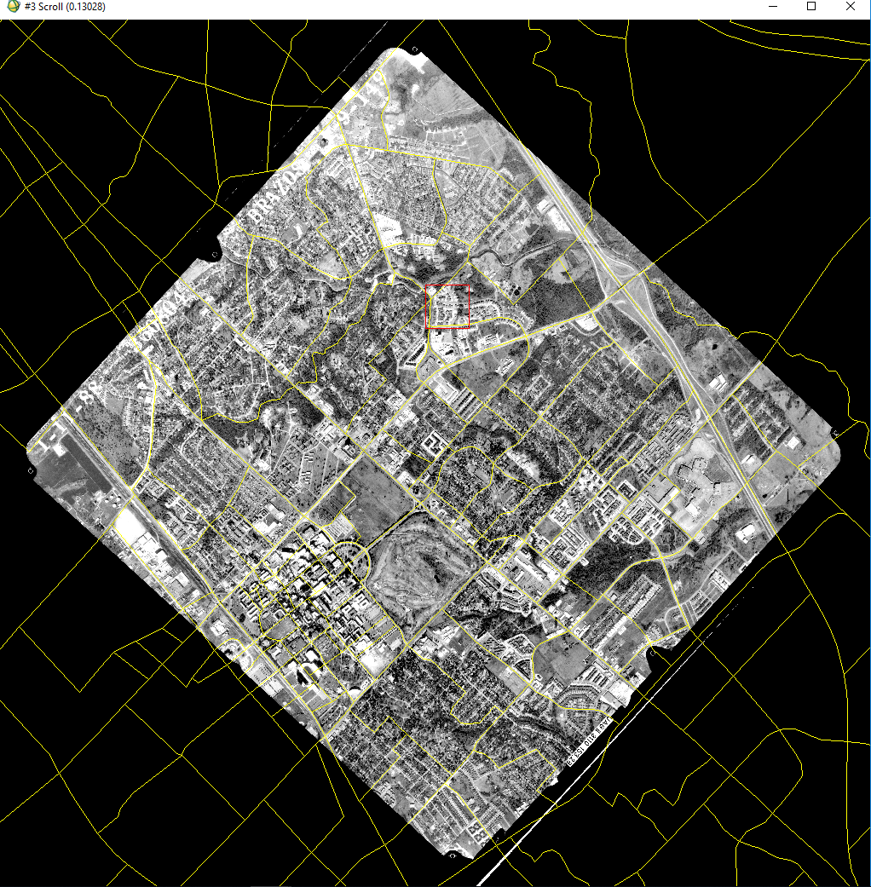

2nd Order:

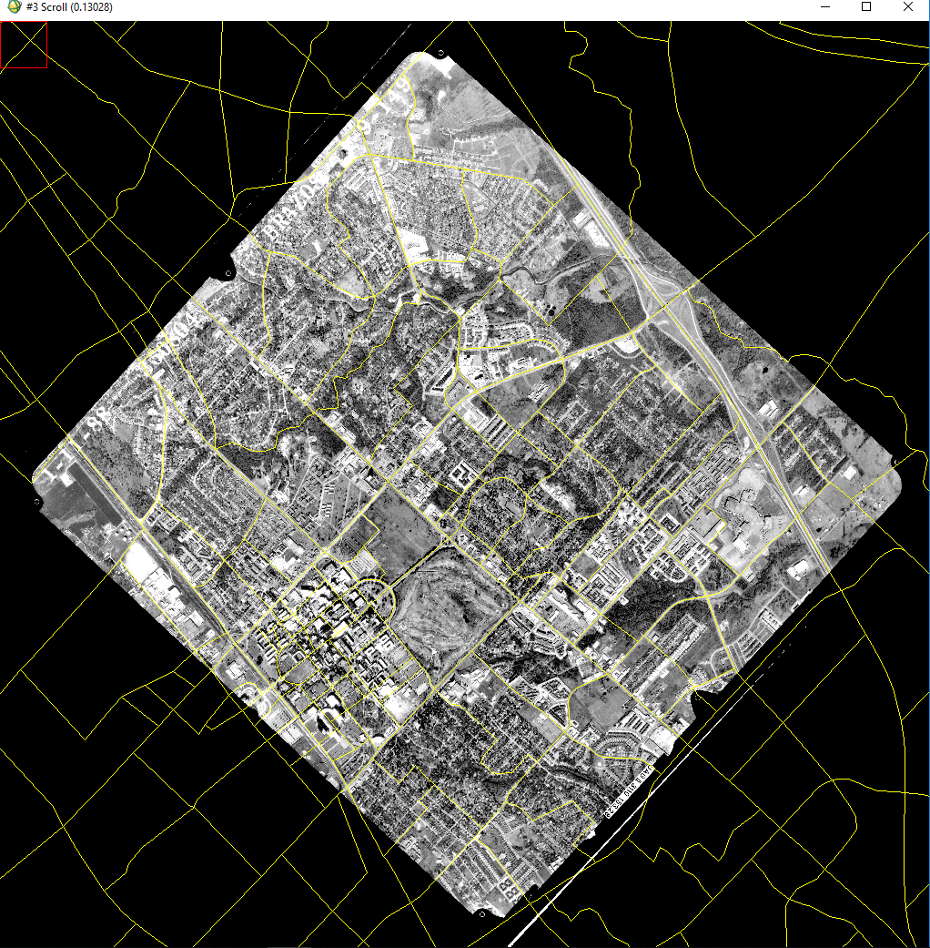

Q8: What are the geocoding differences caused by different resampling methods (nearest neighbor, bilinear, and cubic convolution with the linear polynomial transform)? Include images to illustrate your points.

Compared to Nearest Neighbor, Bilinear seems to have a slight head on accuracy as to the road-border, similar to the improvement from using the 2nd order polynomial earlier. Cubic convolution, however, produced less consistent correlation between roads and borders, especially small, complicated intersections.

Nearest Neighbor shown as 1st order above; image not reinserted to inflate filesize

Bilinear:

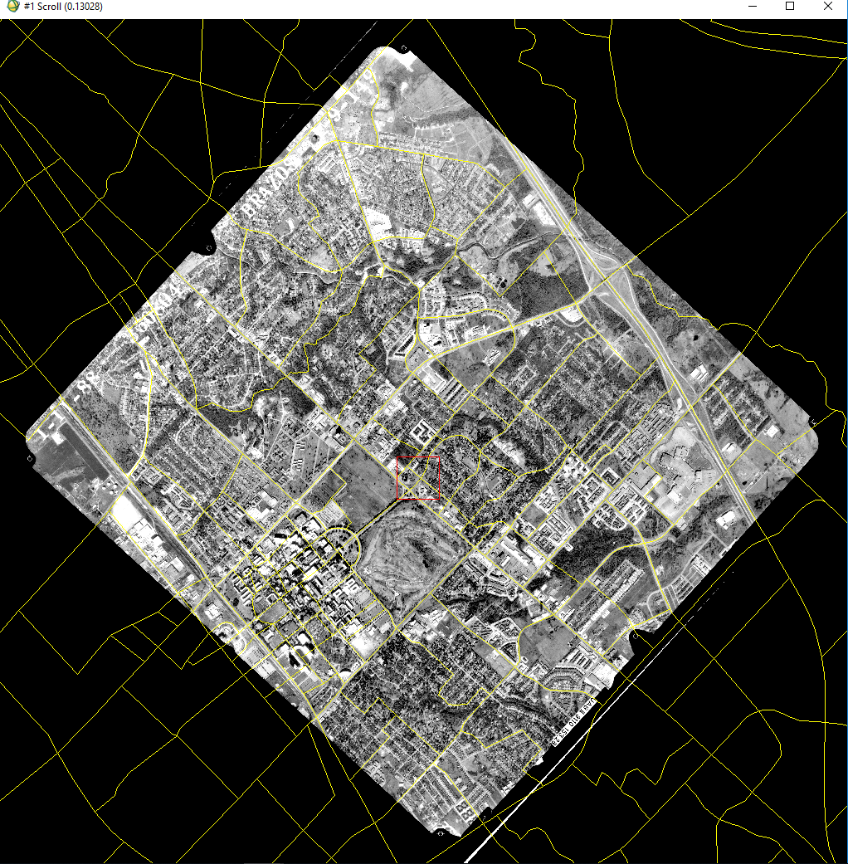

Cubic Convolution:

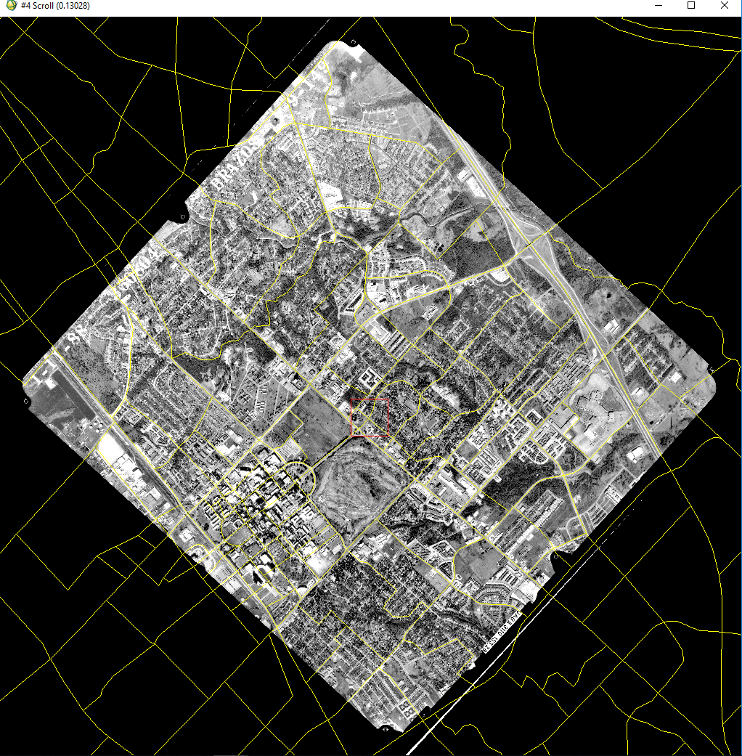

Q9: What changes do you observe when you overlay or compare the georeferenced aerial photography, which was acquired in 1988, with the NAIP image BCS16, which was acquired in 2016, what changes in landscape can you observe? Include a color image map to illustrate your brief description.

Note: As I could not determine another way to overlay in a reasonable amount of time, I did Q10 first and referenced the result of that for an overlay.

The most obvious change to the area is the large amount of new construction in green and blue that shows over the red of the 1988 image as a base. The residential area to the east of campus has also had significant development. Campus itself has a lot of different development, and the additions to Kyle Field are even visible above the outline of the original. The rest of the town seems to be fairly unchanged, due to the red overtaking the blue in the rest of the residential areas.

Q10: Show an image of the aerial88 image warped using a 1st order polynomial displayed as a red band with the BCS16 G Layer in green and the BCS16 B Layer in blue (note: this requires the images to be layer stacked). Use the default UTM (NAD83, zone 14) projection and show the entire image (be “inclusive”).

